z

group members

ahmad maaz (2019043)

ali abdul razzaq (2019058)

taimoor ahmad (2019511)

muteeb ur rehman (2019419)

ahmad hassan (2019041)

*SUBMISSION DATE: 18TH June 2021.*

Contents

1. Introduction 2

2. Project Description 2

User Table 3

Bus Table 3

Routes Table 3

Reservation Table 3

Employees Table 3

Seating Table 3

3. Constraints on Requirements 3

4. Technologies used with description 4

Adobe XD: 4

Lucid chart: 4

Vs. Code: 4

PhpMyAdmin and Oracle XE: 5

5. Entity Relationship Diagram 5

6. Enhanced Entity Relationship Diagram 5

7. ER Schema and Complete Set of Queries 6

Queries Used to Create and Populate Tables 6

Queries Used to Connect Website With Database 8

8. References 9

9. Recorded Presentation Link 9

# Introduction

Transport has always been an issue for students residing in GIKI. A vast majority of GIKIANS are from cities far away from Topi, Swabi, where the Institute is currently located. These students find it very difficult to travel due to the taxing job of getting the bus tickets from the ‘GIKafe’, especially during an ongoing semester or just before the semester breaks due to the busy schedule each student needs to follow.

This coupled with long waiting lines and short time spans for the handing out of bus tickets makes it even more challenging for the students to get these tickets.

Some students might even use previously bought tickets later by forging or altering the date on the ticket, thus causing confusion and over-booking of the already limited number of tickets.

Lastly, if the tickets are sold out, the students would then have to use the local transport, which would waste even more time and prove an even bigger challenge as they are more congested and cost more than the buses the institute itself offers for transportation.

Keeping this problem in mind, we wanted to create an online ticketing website to satisfy and to cater the needs of these GIKIANS.

# Project Description

The main goal of this project was to present a solution to a problem that students at GIK institute face while booking their tickets using our knowledge of this course and we achieved this by making a complete website that provides the user the ability to login to the site via their university provided emails, select their route, and date, and purchase their desired available seat. The site will also show them a ticket which displays all their selected choices.   
Our website also contains a separate admin panel. Which provides the ability for an admin member to either book a seat for himself or another user who is unable to login to the site due to issues such as lack of internet connectivity or a device to open a webpage on. Other than this, an admin member can see how much revenue is generated on each of the routes available or he can see the total revenue. He may also add a route for a later date. Lastly an admin member can see all the employees’ details and the respective bus they work for.

Using HTML and CSS we replicated all the pages that we had already designed in Adobe XD. We also created a database in phpMyAdmin using SQL queries written in oracle and phpMyAdmin.  
lastly, we used php to connect the database with the website we created.  
We devised the following tables to construct our database:

## User Table

|  |  |  |  |  |  |  |  |
| --- | --- | --- | --- | --- | --- | --- | --- |
| USER_ID | USER_FIRST_NAME | USER_LAST_NAME | PHONE_NO | USER_EMAIL | USER_PASSWORD | GENDER | USER_DESIGNATION_CHECK |

## Bus Table

|  |  |  |
| --- | --- | --- |
| REGISTRATION_NO | SEAT_AVAILABLE | BUS_CLASS |

## Routes Table

|  |  |  |  |  |  |
| --- | --- | --- | --- | --- | --- |
| DEPARTURE_LOCATION | ARRIVAL_LOCATION | ROUTE_ID | BUS_REGISTRATION_NO | ROUTE_FARE | DATE_AVAILABLE |

## Reservation Table

|  |  |  |  |  |  |
| --- | --- | --- | --- | --- | --- |
| RESERVATION_ID | USER_ID | ROUTE_ID | BUS_REGISTRATION_NO | SEAT_ID | DATE_CHOOSEN |

## Employees Table

|  |  |  |  |  |  |
| --- | --- | --- | --- | --- | --- |
| NAME | PHONE_NO | DESIGNATION | EMPLOYEE_ID | BUS_REGISTRATION_NO | SALARY |

## Seating Table

|  |  |  |
| --- | --- | --- |
| SEAT_ID | BUS_REGISTRATION_NO | AVAILABILITY |

# Constraints on Requirements

The biggest difficulty we faced while making our project was coordinating remotely between the team. Due to the ongoing corona virus situation, we were unable to physically gather at one place. We decided to use MS Teams and go online to make our project. We faced many communications and internet connectivity issues which affected our progress and performance as well.

Some good software’s that we used for our project were paid, hence we opted for their free version restricting us to remain only on the free features they provided.

Although the time provided for the project was ample if the team members were present together in the university, since we were working remotely, the progress was much slower than it would have been if all of us were present within the campus.

# Technologies used with description

## Adobe XD:

To make an efficient and effective website, we first made a prototype of its appearance which would help in improving its overall design and more importantly, help in the development of the site as we could then view the possible end result and thus perform tweaks to get the desired result.

─ Purpose-built: Adobe XD is a purpose-built software whose sole purpose is to make prototypes for websites, applications, and other digital products. It comes with many features that prove its superiority over other alternate choices.

─ Features like those in Adobe Photoshop: Adobe Photoshop was formerly used by developers for designing prototypes. Since both XD and Photoshop are from adobe, XD inherits some of the more useful features of Photoshop, hence proving itself as a strong candidate for being a prototype developing tool.

We used Adobe XD to make samples of how our websites should look like.

## Lucid chart:

It is important to form an entity relation diagram before developing the actual database, and with Lucid chart, we did so online, with an easy-to-understand user interface.

─ Free to use for students: lucid chart enables its users to use its features for free if they sign up with their educational emails.

─ Easier collaboration: the software enables its user to share and collaborate their work with their colleagues, unlike many others.

In our project we used Lucid chart to create our ERD and EERD.

## Vs. Code:

Making the website was one of our main and final goals. Vs Code gave us the ability to work with different languages simultaneously.

─ Extensions: the most defining feature of VS Code is its extensions which let the environment support multiple languages. This makes it one of the most powerful tools that serve its purpose.

─ Free to use: Vs code is an open-source software that anyone can download for free which makes it a very ideal choice for students and professionals.

Vs code helped us to write queries of our HTML/CSS code for the front-end of the project.

PhpMyAdmin and Oracle XE:

These free-to-use tools enable users to create, drop, alter and view databases. It also allows many other features in a user-friendly manner.

We used PhpMyAdmin and Oracle XE to create our database and write queries related to it.

# Entity Relationship Diagram

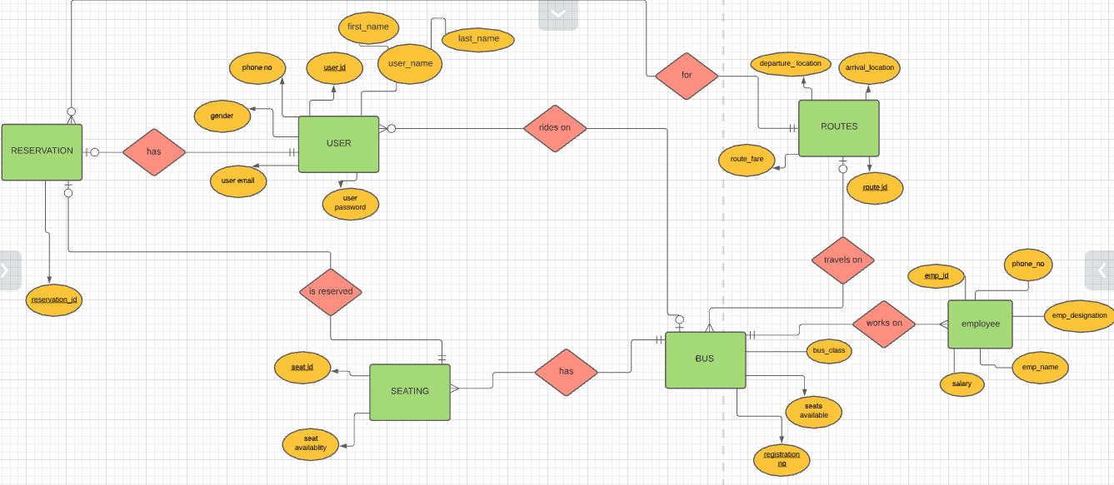

# Enhanced Entity Relationship Diagram

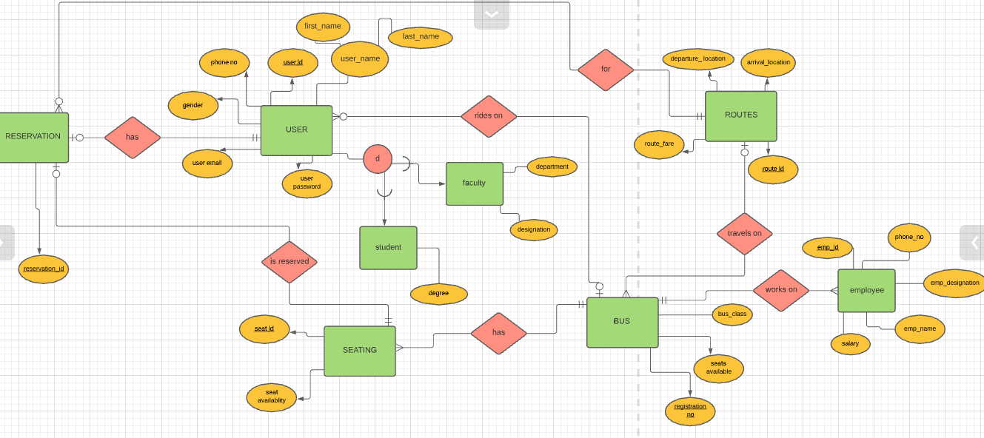

# ER Schema and Complete Set of Queries

Queries Used to Create and Populate Tables

CREATE TABLE USERS(USER_ID INTEGER,USER_FIRST_NAME VARCHAR(20),USER_LAST_NAME VARCHAR(30),PHONE_NO INTEGER,USER_EMAIL VARCHAR(40),USER_PASSWORD VARCHAR(15),GENDER VARCHAR(10),USER_DESIGNATION_CHECK INTEGER,PRIMARY KEY(USER_ID));

CREATE TABLE BUS(REGISTRATION_NO VARCHAR(10),SEATS_AVAILABLE INTEGER,BUS_CLASS VARCHAR(20),PRIMARY KEY(REGISTRATION_NO));

CREATE TABLE ROUTES(DEPARTURE_LOCATION VARCHAR(20),ARRIVAL_LOCATION VARCHAR(20),ROUTE_ID INTEGER,BUS_REGISTRATION_NO VARCHAR(10),ROUTE_FARE INTEGER,PRIMARY KEY(ROUTE_ID),FOREIGN KEY(BUS_REGISTRATION_NO) REFERENCES BUS(REGISTRATION_NO));

CREATE TABLE SEATING(SEAT_ID INTEGER,BUS_REGISTRATION_NO VARCHAR(10),AVAILABILITY INTEGER,PRIMARY KEY(SEAT_ID,BUS_REGISTRATION_NO),FOREIGN KEY(BUS_REGISTRATION_NO) REFERENCES BUS(REGISTRATION_NO));

CREATE TABLE RESERVATION(RESERVATION_ID INTEGER,USER_ID INTEGER,ROUTE_ID INTEGER,SEAT_ID INTEGER,BUS_REGISTRATION_NO VARCHAR(10),PRIMARY KEY(RESERVATION_ID),FOREIGN KEY(USER_ID) REFERENCES USERS(USER_ID),FOREIGN KEY(ROUTE_ID) REFERENCES ROUTES(ROUTE_ID),FOREIGN KEY(SEAT_ID,BUS_REGISTRATION_NO) REFERENCES SEATING(SEAT_ID,BUS_REGISTRATION_NO));

CREATE TABLE EMPLOYEES(NAME VARCHAR(30),PHONE_NO INTEGER,DESIGNATION VARCHAR(20),EMPLOYEE_ID INTEGER,BUS_REGISTRATION_NO VARCHAR(10),SALARY INTEGER,FOREIGN KEY(BUS_REGISTRATION_NO) REFERENCES BUS(REGISTRATION_NO),PRIMARY KEY(EMPLOYEE_ID));

INSERT ALL INTO USERS VALUES(2019043,'AHMAD','MAAZ',03356763938,'U2019043@GIKI.EDU.PK','A.MAAZ','MALE',1)

INTO USERS VALUES(2201,'ZAHID','HALIM',03356769938,'ZAHIDHALIMECS@GIKI.EDU.PK','Z.HALIME','MALE',2)

INTO USERS VALUES(3301,'FAHEEM','AKHTAR',03356763956,'FAHEEMAKHTARAD@GIKI.EDU.PK','F.AKHTAR','MALE',3)

SELECT * FROM DUAL;

INSERT ALL INTO BUS VALUES('LEE-1234',44,'ECONOMY')

INTO BUS VALUES('LEB-4321',34,'BUSINESS')

INTO BUS VALUES('LEE-5678',44,'ECONOMY')

INTO BUS VALUES('LEB-8765',34,'BUSINESS')

SELECT * FROM DUAL;

INSERT ALL INTO ROUTES VALUES('GIKI','ISLAMABAD',111,'LEE-1234','300')

INTO ROUTES VALUES('GIKI','LAHORE',222,'LEB-4321','1500')

INTO ROUTES VALUES('ISLAMABAD','GIKI',333,'LEE-5678','300')

INTO ROUTES VALUES('LAHORE','GIKI',444,'LEB-8765','1500')

SELECT * FROM DUAL;

INSERT ALL INTO SEATING VALUES(01,'LEE-1234',1)

INTO SEATING VALUES(02,'LEE-1234',1)

INTO SEATING VALUES(03,'LEE-1234',1)

INTO SEATING VALUES(04,'LEE-1234',0)

INTO SEATING VALUES(05,'LEE-1234',1)

INTO SEATING VALUES(01,'LEB-4321',0)

INTO SEATING VALUES(02,'LEB-4321',1)

INTO SEATING VALUES(03,'LEB-4321',0)

INTO SEATING VALUES(04,'LEB-4321',0)

INTO SEATING VALUES(05,'LEB-4321',1)

INTO SEATING VALUES(01,'LEE-5678',0)

INTO SEATING VALUES(02,'LEE-5678',1)

INTO SEATING VALUES(03,'LEE-5678',1)

INTO SEATING VALUES(04,'LEE-5678',1)

INTO SEATING VALUES(05,'LEE-5678',1)

INTO SEATING VALUES(01,'LEB-8765',0)

INTO SEATING VALUES(02,'LEB-8765',0)

INTO SEATING VALUES(03,'LEB-8765',1)

INTO SEATING VALUES(04,'LEB-8765',0)

INTO SEATING VALUES(05,'LEB-8765',1)

SELECT * FROM DUAL;

INSERT ALL INTO RESERVATION VALUES(1212,2019043,111,01,'LEE-1234')

INTO RESERVATION VALUES(1313,2201,222,05,'LEB-4321')

INTO RESERVATION VALUES(1414,3301,333,03,'LEE-5678')

SELECT * FROM DUAL;

INSERT ALL INTO EMPLOYEES VALUES('ASGHAR',0330656964,'DRIVER',09,'LEE-1234','100')

INTO EMPLOYEES VALUES('SOHAIL',0335656964,'DRIVER',08,'LEB-4321','10000')

INTO EMPLOYEES VALUES('ALI',0335656964,'DRIVER',07,'LEE-5678','10000')

INTO EMPLOYEES VALUES('HASSAN',0335656964,'DRIVER',06,'LEB-8765','10000')

INTO EMPLOYEES VALUES('RUKHSANA',0330656964,'HOSTESS',99,'LEE-1234','10000')

INTO EMPLOYEES VALUES('FARZANA',0335656964,'HOSTESS',88,'LEB-4321','10000')

INTO EMPLOYEES VALUES('SAHKEELA',0335656964,'HOSTESS',77,'LEE-5678','10000')

INTO EMPLOYEES VALUES('ABIDA',0335656964,'HOSTESS',66,'LEB-8765','10000')

SELECT * FROM DUAL;

## Queries Used to Connect Website With Database

insert into reservation(USER_ID,ROUTE_ID,SEAT_ID,BUS_REGISTRATION_NO,DATE_CHOSEN)values('$inp1','$inp2','$inp3','$inp4','$inp5');

update seating set AVAILABILITY='$inp6' where SEAT_ID='$inp3'AND BUS_REGISTRATION_NO='$inp4';

SELECT routes.ROUTE_ID,routes.DEPARTURE_LOCATION,routes.ARRIVAL_LOCATION,SUM(ROUTE_FARE) FROM reservation INNER JOIN routes where routes.ROUTE_ID=reservation.ROUTE_ID GROUP BY routes.ROUTE_ID;

SELECT SUM(ROUTE_FARE) FROM reservation INNER JOIN routes where routes.ROUTE_ID=reservation.ROUTE_ID;

select * from seating;

SELECT RESERVATION_ID,USER_ID,ROUTE_ID,SEAT_ID,BUS_REGISTRATION_NO,DATE_CHOSEN FROM reservation;

select * from users;

select * from routes;

SELECT NAME,PHONE_NO,DESIGNATION,EMPLOYEE_ID,BUS_REGISTRATION_NO,SALARY FROM employees;

insert into routes(DEPARTURE_LOCATION,ARRIVAL_LOCATION,ROUTE_ID,BUS_REGISTRATION_NO,ROUTE_FARE,DATE_AVAILAIBLE)values('$inp1','$inp2','$inp5','$inp3','$inp6','$inp4');

# References

[26: POST and GET Superglobals in PHP | PHP Tutorial | Learn PHP Programming | PHP for Beginners - YouTube](https://www.youtube.com/watch?v=pkxqlfLioCk&list=PL0eyrZgxdwhwBToawjm9faF1ixePexft-&index=27)

[28: How to Start a Session in PHP | PHP Tutorial | Learn PHP Programming | PHP for Beginners - YouTube](https://www.youtube.com/watch?v=3CS-eQdcMLU&list=RDCMUCzyuZJ8zZ-Lhfnz41DG5qLw&index=16)

[36: How to connect to a database in PHP | PHP tutorial | Learn PHP programming - YouTube](https://www.youtube.com/watch?v=ILyf16MEvHM&list=PL0eyrZgxdwhwBToawjm9faF1ixePexft-&index=38)

[37: How to show database data on a website using MySQLi | PHP tutorial | Learn PHP programming - YouTube](https://www.youtube.com/watch?v=0YLJ0uO6n8I&list=PL0eyrZgxdwhwBToawjm9faF1ixePexft-&index=37)

[38: Insert data from a website into a database using MySQLi | PHP tutorial | Learn PHP programming - YouTube](https://www.youtube.com/watch?v=XhLAB1wwzNk&list=PL0eyrZgxdwhwBToawjm9faF1ixePexft-&index=38)

https://code.tutsplus.com/tutorials/how-to-use-sessions-and-session-variables-in-php--cms-31839

# Recorded Presentation Link

<https://youtu.be/knpvKvpHTSE>